**Implementing Web Application**

**Solution Requirements (Functional & Non-functional)**

|  |  |
| --- | --- |
| **Date** | 12 November 2022 |
| **Team ID** | PNT2022TMID13118 |
| **Project Name** | News Tracker Application |
| **Maximum Marks** | 4 Marks |

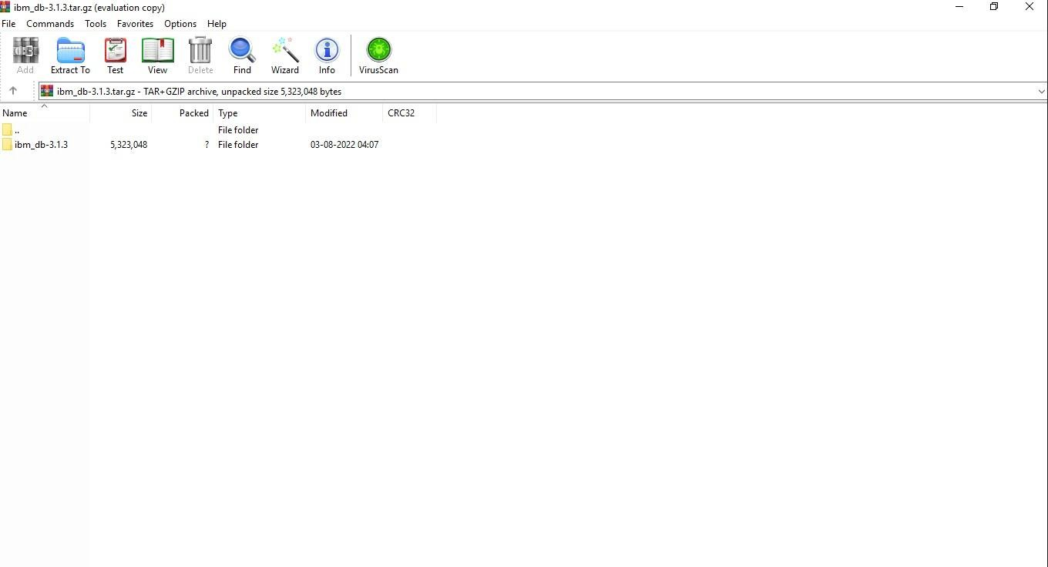

Create IBM DB2 and connect with python